Section II: The Amendments
The nation that the Founders wanted to perfect in 1787 consisted of fewer than 4 million people living in 13 agricultural states along the Atlantic coast of North America. More than two centuries later, that same Constitution provides the foundation for governing an industrial and highly technological nation of more than 285 million people in 50 states spread across the continent and beyond. The priceless heritage of the Constitution has been in its ability to adapt to new conditions while preserving the basic form of American government. The words of Chief Justice Marshall in 1819 remain true today: “ We must never forget that it is…a Constitution intended to endure the ages to come, and, consequently, to be adapted to various crises of human affairs.” (United States Government: Democracy in Action, pg. 76)
The Amendment Process
- _______________________________ describes how Congress and the states can change the Constitution.
- There are __________________________ for amending the Constitution; however, only __________ has been used. Both methods consist of _________________________ and ________________________________.
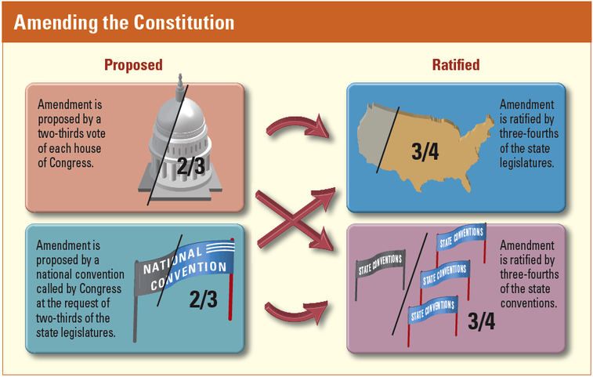
Study the graphic above and summarize the process for proposing and ratifying an amendment. _________________
________________________________________________________________________________________________
________________________________________________________________________________________________
________________________________________________________________________________________________
Despite the difficulty of the amendment process, Americans put it to work almost before the ink was dry on the new constitution. Because critics attacked the Constitution for not protecting the rights of the people, the Founders promised to add a list of such rights. In _____________________, the states ratified 10 amendments which became known as ____________________________________________.
The Bill of Rights
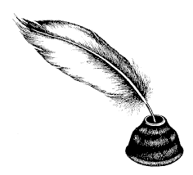
- Contains______________________________________________________
- Limits ________________________________________________________
- Protects ______________________________________________________

- The First Amendment - ____________________________________________________________________
________________________________________________________________________________________
________________________________________________________________________________________
- Freedom Within Limits – The freedoms of speech and the press are not unlimited. For example, the law prohibits _______________________________ and ______________________________.
  - Slander - ___________________________________________________________________
___________________________________________________________________________

  - Libel - _____________________________________________________________________
___________________________________________________________________________
- Additional Limits
  - ___________________________________________________________________________
  - ___________________________________________________________________________
    - You can sign petitions and contact government leaders if you disagree.
- Another freedom protected is the right to assemble in groups or hold demonstrations. Courts have ruled that the government can require a permit.

- The Second Amendment - __________________________________________________________________
________________________________________________________________________________________
________________________________________________________________________________________

- The Third Amendment - ____________________________________________________________________
________________________________________________________________________________________
________________________________________________________________________________________

- The Fourth Amendment - ___________________________________________________________________
________________________________________________________________________________________
________________________________________________________________________________________
- To be lawful, a search or arrest must be based on ______________________________________, meaning that police must have a reasonable basis to believe the person or premises is linked to a crime.
- A search or an arrest also usually requires a __________________________________________ or ______________________________________. These must be signed by a judge.

- The Fifth Amendment - This amendment contains four important protections for people accused of crimes.
- __________________________________________________________________________________________________________________________________________________________________________

- _____________________________________________________________________________________
_____________________________________________________________________________________

- _____________________________________________________________________________________
_____________________________________________________________________________________

- _____________________________________________________________________________________
_____________________________________________________________________________________

- The Fifth Amendment also defines government’s right of ___________________________________. This is the power of the government to take private property for public use such as ______________
_________________________, ___________________________, or a _______________________. The government must pay a fair price for the property and must use it in a way that benefits the public.

- The Sixth Amendment - ____________________________________________________________________
________________________________________________________________________________________
________________________________________________________________________________________
________________________________________________________________________________________
________________________________________________________________________________________

- The Seventh Amendment - _________________________________________________________________
________________________________________________________________________________________
________________________________________________________________________________________

- The Eighth Amendment - __________________________________________________________________
________________________________________________________________________________________
________________________________________________________________________________________

- The Ninth Amendment - ____________________________________________________________________
________________________________________________________________________________________
________________________________________________________________________________________

- The Tenth Amendment - ___________________________________________________________________
________________________________________________________________________________________
________________________________________________________________________________________

Additional Amendments
- The Eleventh Amendment __________________________________________________________________ federal court by citizens of another state.

- The Twelfth Amendment provides that the _____________________________________ shall cast separate ballots for president and vice-president.
  - The electoral college ______________________________________________________________
_______________________________________________________________________________
_______________________________________________________________________________

- The Thirteenth, Fourteenth, and Fifteenth Amendments( often called the ____________________________ ___________________________ because they grew out of that great conflict) _______________________ ___________________________, ____________________________________________________________ ____________________________________________________________________________________, and ________________________________________________________________________________________.

- The later amendments, Sixteen through Twenty-Seven, deal with a wide variety of topics reflecting changes in modern times.

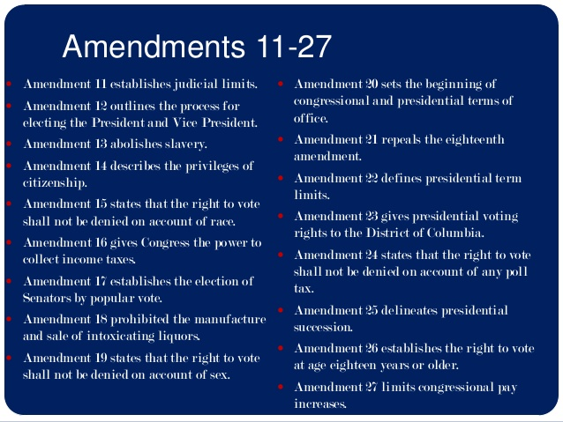
Read through the amendments on the above chart and answer the questions below.
- Which amendment gave women the right to vote? _________________________________________________
- Which amendment outlaws slavery? _____________________________________________________________
- Which amendment repealed the 18th Amendment? _________________________________________________

- More than 10,000 proposals for amendments to the Constitution have been introduced in Congress since 1789. What are TWO current issues that you feel need to be addressed and considered as an amendment?

  - ___________________________________________________________________________________
___________________________________________________________________________________

  - ___________________________________________________________________________________
___________________________________________________________________________________
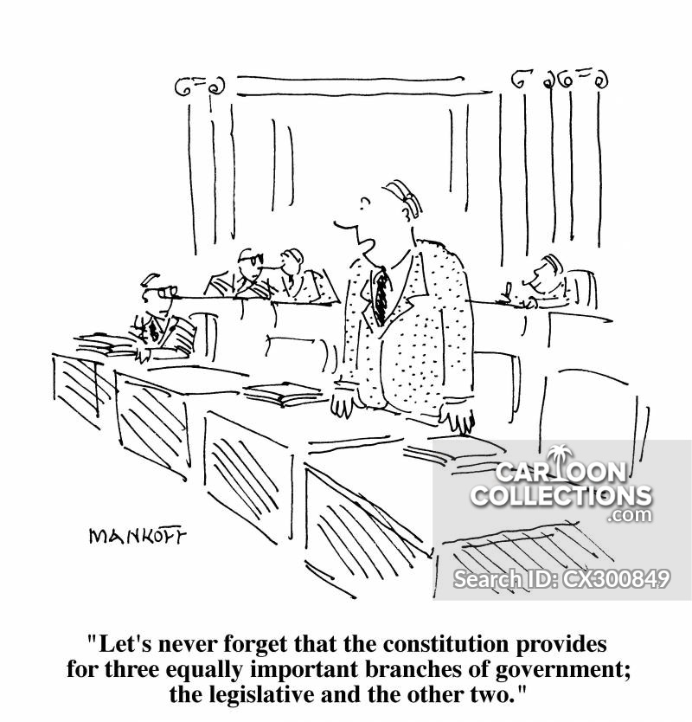

- Which branch of government does the cartoonist imply is the most important? __________________

- Do you think the writers of the Constitution believed one branch of government was more important

than the other two? Explain. _________________________________________________________

_________________________________________________________________________________

_________________________________________________________________________________

- Do you think one branch of government holds more power than the other two? Explain. _________

_________________________________________________________________________________

_________________________________________________________________________________

